**Ex. No. :1 Date: 9/9/2025**

**Register No.: 231701039 Name: Prasanna R**

# AIM:

**Bresenham’s Line Algorithm, Midpoint Circle Algorithm, and Midpoint Ellipse Algorithm**



To implement:

* Bresenham’s Line Drawing Algorithm
* Midpoint Circle Drawing Algorithm
* Midpoint Ellipse Drawing Algorithm

And draw geometric shapes on the screen.

# Procedure:

1. Initialize graphics mode using suitable graphics libraries (e.g., OpenGL in C++, turtle or matplotlib in Python).
2. For each algorithm:
   * Accept user input for coordinates or radius.
   * Implement the plotting logic using the respective algorithm.
   * Plot the pixels on the screen.

***Program:***

import matplotlib.pyplot as plt

def plot_point(x, y): plt.plot(x, y, 'bo')

def bresenham_line(x1, y1, x2, y2): dx = abs(x2 - x1)

dy = abs(y2 - y1) x, y = x1, y1

sx = 1 if x2 > x1 else -1 sy = 1 if y2 > y1 else -1 if dx > dy:

err = dx / 2.0 while x != x2:

plot_point(x, y)

.

err -= dy if err < 0:



y += sy err += dx

x += sx

else:

err = dy / 2.0 while y != y2:

plot_point(x, y) err -= dx

if err < 0: x += sx

err += dy y += sy

plot_point(x, y)

def midpoint_circle(xc, yc, r): x = 0

y = r

p = 1 - r while x <= y:

for a, b in [(x, y), (y, x), (-x, y), (-y, x),

(-x, -y), (-y, -x), (x, -y), (y, -x)]:

plot_point(xc + a, yc + b) x += 1

if p < 0:

p += 2*x + 1 else:

y -= 1

p += 2*(x - y) + 1

def midpoint_ellipse(rx, ry, xc, yc): x, y = 0, ry

rx2, ry2 = rx**2, ry**2

p1 = ry2 - (rx2 * ry) + (0.25 * rx2) dx = 2 * ry2 * x

dy = 2 * rx2 * y

while dx < dy:

for a, b in [(x, y), (-x, y), (x, -y), (-x, -y)]: plot_point(xc + a, yc + b)

x += 1

dx = 2 * ry2 * x if p1 < 0:

.

p1 += dx + ry2 else:



y -= 1

dy = 2 * rx2 * y

p1 += dx - dy + ry2

p2 = (ry2 * (x + 0.5)**2) + (rx2 * (y - 1)**2) - (rx2 * ry2) while y >= 0:

for a, b in [(x, y), (-x, y), (x, -y), (-x, -y)]: plot_point(xc + a, yc + b)

y -= 1

dy = 2 * rx2 * y if p2 > 0:

p2 -= dy + rx2 else:

x += 1

dx = 2 * ry2 * x

p2 += dx - dy + rx2

plt.figure(figsize=(8, 8))

bresenham_line(10, 10, 100, 50)

midpoint_circle(100, 100, 40)

midpoint_ellipse(60, 30, 200, 200) plt.gca().set_aspect('equal', adjustable='box') plt.grid(True)

plt.show()

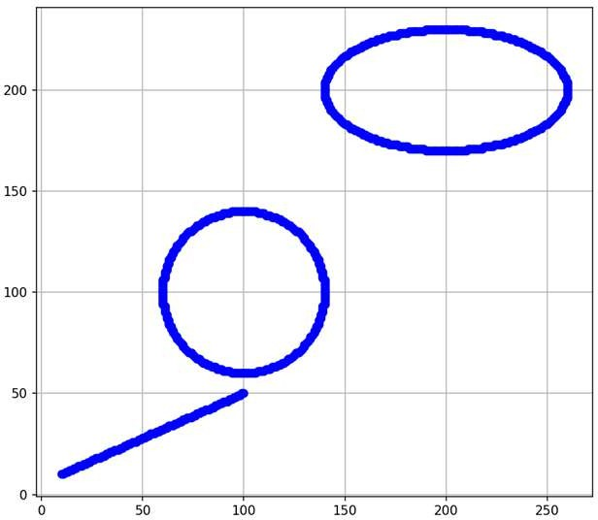

**Result:**

Thus, the line, circle, and ellipse were successfully drawn using Bresenham's and Midpoint algorithms.

.